Nevis Cup 2018
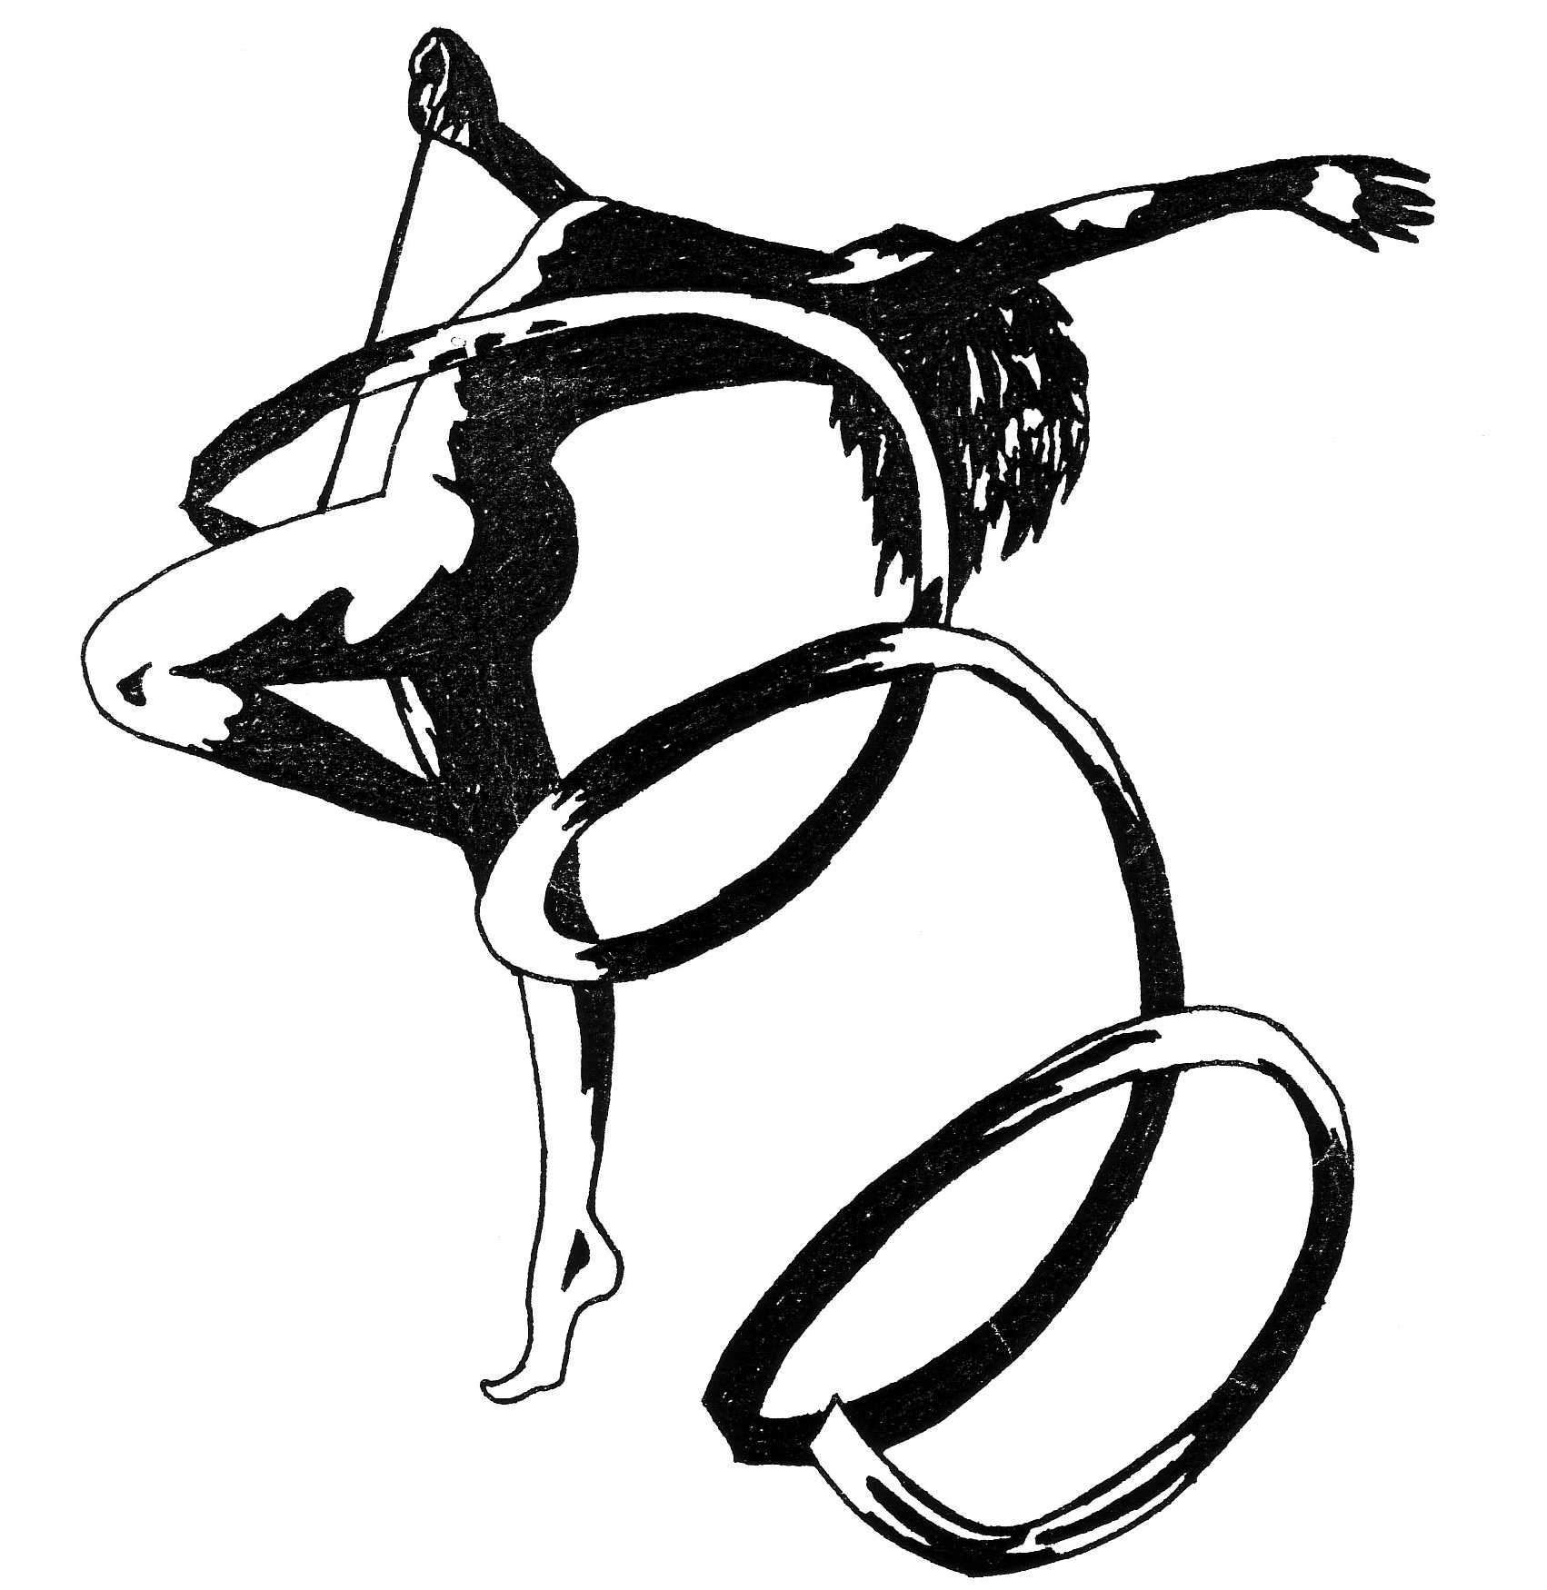
Nevis RG, Sweden invites you to our 21:st international meet in Rhythmic Gymnastics.

The competition will be arranged in Staffanstorp, December 1. The competition is sanctioned by the Swedish Gymnastic Federation. ( Staffanstorp is a village just outside the city of Malmö. Malmö has an airport but Copenhagen and a short traintrip is convenient too.)
Sporthall: Hagalidhallen, Hagalidvägen, Staffanstorp
Groups Children (born 2006-2009) one program without apparatus 5-6 gymnasts. Time 1.45-2.00 minutes. Max 6 D (min 1 jump,1balance,1 rotation), Max 6 points, min 4 collaborations, min 2 dance-steps comb. formations min 5.

DTQ (duo,trio,quarto) Nordic rules, just ask if you do not know the norms and we will send.
Children ( born 2007- 2009) one program without apparatus and one of own choice. CoP as for juniors but no claim to include DER. Without apparatus min 1, max 2 acrobatic combinations ( min 2 rotations, max 4 in same combination and include min 1 pre-acrobatic element)

Pre-juniors (born 2006) two programs of own choice. CoP same as for Children).

Individual Juniors (born 2003-2005 ) FIG norms, three routines free choice of apparatus. CoP juniors

Individual Seniors (born 2002 and earlier) FIG norms, three routines free choice of apparatus. CoP seniors

Registration fee: 30 euro ind.gymnast. 50 euro DTQ. 100 euro groups.
To be paid in the sporthall.

Arrival day: Friday afternoon November 30.
Free training during the evening.
Technical meeting , Competition Saturday December 1.
Departure day: Sunday morning December 2.

Last day of registation October 22 to:
eva.nevisrg@gmail.com
Nevis RG co/ Eva Rodriguez Järneksv.6 24544 Staffanstorp Sweden
OBS! All registration will be confirmed by an e- mail. If not then the registration has not reached us and please contact us by a new mail or by post.

All gymnasts, coaches etc shall be insured by their own club.

This hotel has taken contact with us and has promised a nice prize for gymnasts taking part in Nevis Cup. When booking mention Nevis Cup. It is also possible to stay in hostfamilies for free.

Julia Lindén
Sales Executive
Dir +46 46 270 37 67
SMS +46 70 160 27 67
julia.linden@rezidorparkinn.com
www.parkinn.com/hotel-lund
Park Inn by Radisson, Lund
Hedvig Möllers gata 2, SE-223 55 Lund
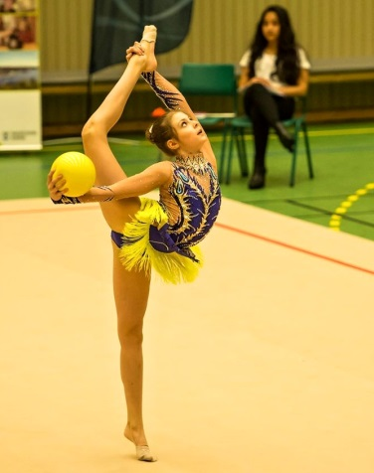 Welcome Nevis RGK

