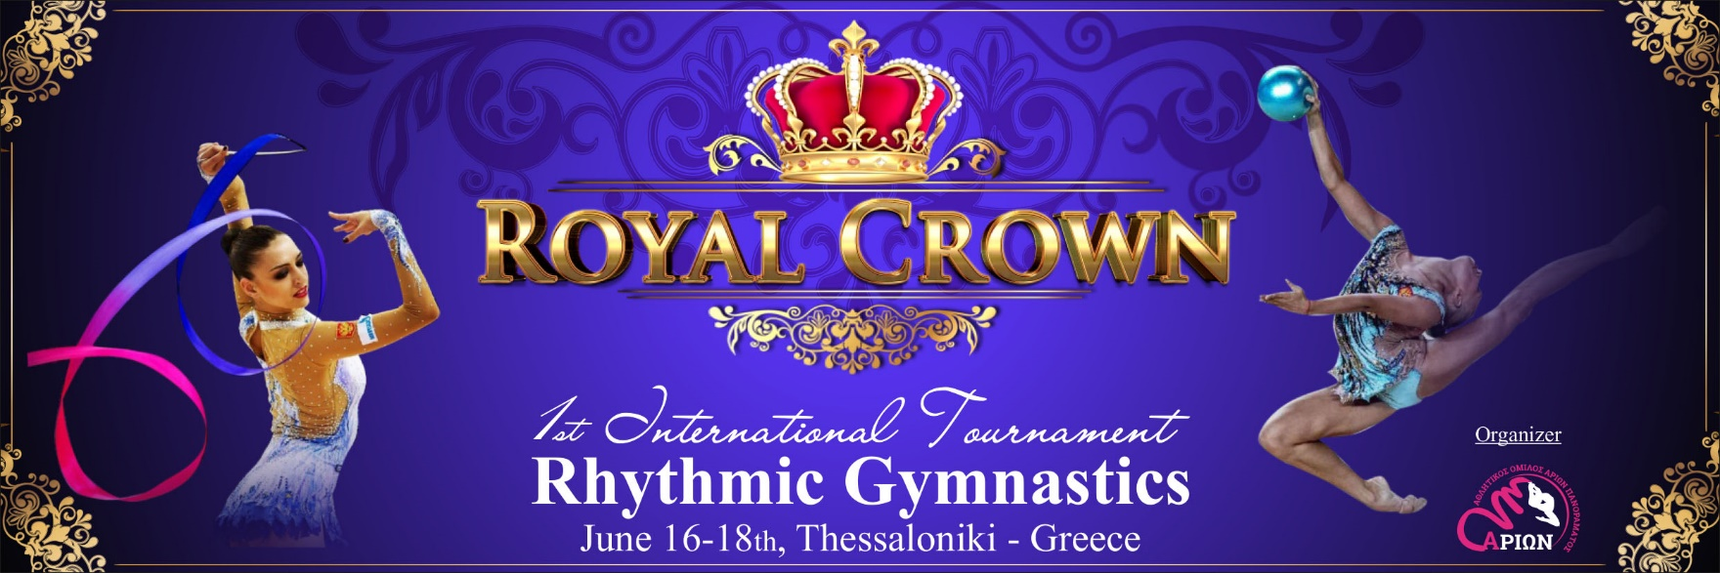

Dear RG Friends!

We have the pleasure of inviting you to participate in the 1st “ROYAL CROWN”CUP for Individual Senior, Junior, Pre-Junior, Hopes, Children and Minis Gymnasts and Junior and Senior Groups which will take place in Thessaloniki from 16th until 18th June, 2017.

Organizing Committee

President: Elena Kaitezidou
General Secretary: Alex Maikousis
Contact person: Dmitry Rykunov
Phone: +306986003625
E-mail: info@arion-exantas.gr
Web: http://www.arion-exantas.gr

Date
16-18 June 2017
Venue
PAOK Sports Arena (Palataki)

Schedule
Arrival of Delegations, Training Thursday, 15th June, 2017.
Judges’ meeting, Competition Friday, 16th June, 2017.
Judges’ meeting, Competition Saturday, 17th June, 2017.
Thessaloniki Tour, Competition Sunday, 18th June, 2017.
Departure of Delegations Monday, 19th June, 2017.

Categories –Requirements
Individual
- Juniors –Seniors
FIG regulations
 | LEVEL A |  | LEVEL B
Seniors | FIG requirements (4 apparatus)
Juniors  2002-2003-2004 | FIG requirements (3 apparatus by choice)
Pre-Juniors  2005-2006 | 2 apparatus by choice  BD: min. 3 - max. 7, max 0.50 point/BD D max: 6.00 p., min. 2 S, min 1 R, AD no min/max. |  | 2 apparatus by choice  BD: min. 3 - max. 7, max 0.50 point/BD D max: 5.00 p., min. 2 S, min 1 R, AD no min/max.
Hopes  2007-2008 | without apparatus  BD: min. 3 - max. 9, max 0.50 point/BD D max: 5.00 p., min. 2 S, min 1 R | 1 apparatus by choice  BD: min. 3 - max. 7, max 0.50 point/BD D max: 5.00 p., min. 2 S, min 1 R, AD no min/max. | without apparatus  BD: min. 3 - max. 7, max 0.40 point/BD D max: 4.00 p., min. 2 S, min 1 R | 1 apparatus by choice  BD: min. 3 - max. 7, max 0.50 point/BD D max: 4.00 p., min. 2 S, min 1 R, AD no min/max.
Children  2009 | without apparatus  BD: min. 3 - max. 9, max 0.50 point/BD D max: 4.00 p., min. 2 S, min.1 R | 1 apparatus by choice  BD: min. 3 - max. 7, max 0.50 point/BD D max: 4.00 p., min. 2 S, min.1 R, AD no min/max. | without apparatus  BD: min. 3 - max. 9, max 0.50 point/BD D max: 3.00 p., min. 2 S, min.1 R | 1 apparatus by choice  BD: min. 3 - max. 7, max 0.50 point/BD D max: 3.00 p., min. 2 S, min.1 R, AD no min/max.
Minis  2010-11 | without apparatus  BD: min. 3 - max. 9, max 0.50 point/BD D max: 3.00 p., min. 2 S, min.1 R

Groups requirements
Hopes Group 2007-2008 (5 balls)
Difficulty without Exchanges:  BD | Difficulty with Exchange:  ED | Dance Steps Combination  S | Dynamic Element with Rotation  R | Collaboration  C
Min. 3 | Min. 3 | Min.2 | Max.1 | Min. 4
Max. 7(1 by choice)
Pre-Juniors Group 2005-2006 (5 hoops)
Difficulty without Exchanges:  BD | Difficulty with Exchange:  ED | Dance Steps Combination  S | Dynamic Element with Rotation  R | Collaboration  C
Min. 3 | Min. 3 | Min.2 | Max.1 | Min. 4
Max. 7(1 by choice)

Junior Group 2002-2003-2004 | FIG requirements
Seniors Group 2001 and earlier | FIG requirements
Apparatus awards (all apparatus in each category)
The top 8 places in each category, in each apparatus. The results will be separated by year.
Individual all around (all categories)
- First 3 places will be awarded with medals: Gold -Silver-Bronze.
- Gymnasts in position 4 - 8 will be awarded with honor diplomas.
For the 1st place in Individual Juniors and Seniors it will be a Crown Award.
Apparatus awards (all apparatus in each category)
- In each category the 3 first gymnasts will be awarded with medals: Gold-Silver-Bronze.
- Gymnasts in position 4 - 8 will be awarded with honor diplomas.
Group awards
- The first 3 groups in each category will be awarded with cup (medals for all their gymnasts): Gold-Silver-Bronze.
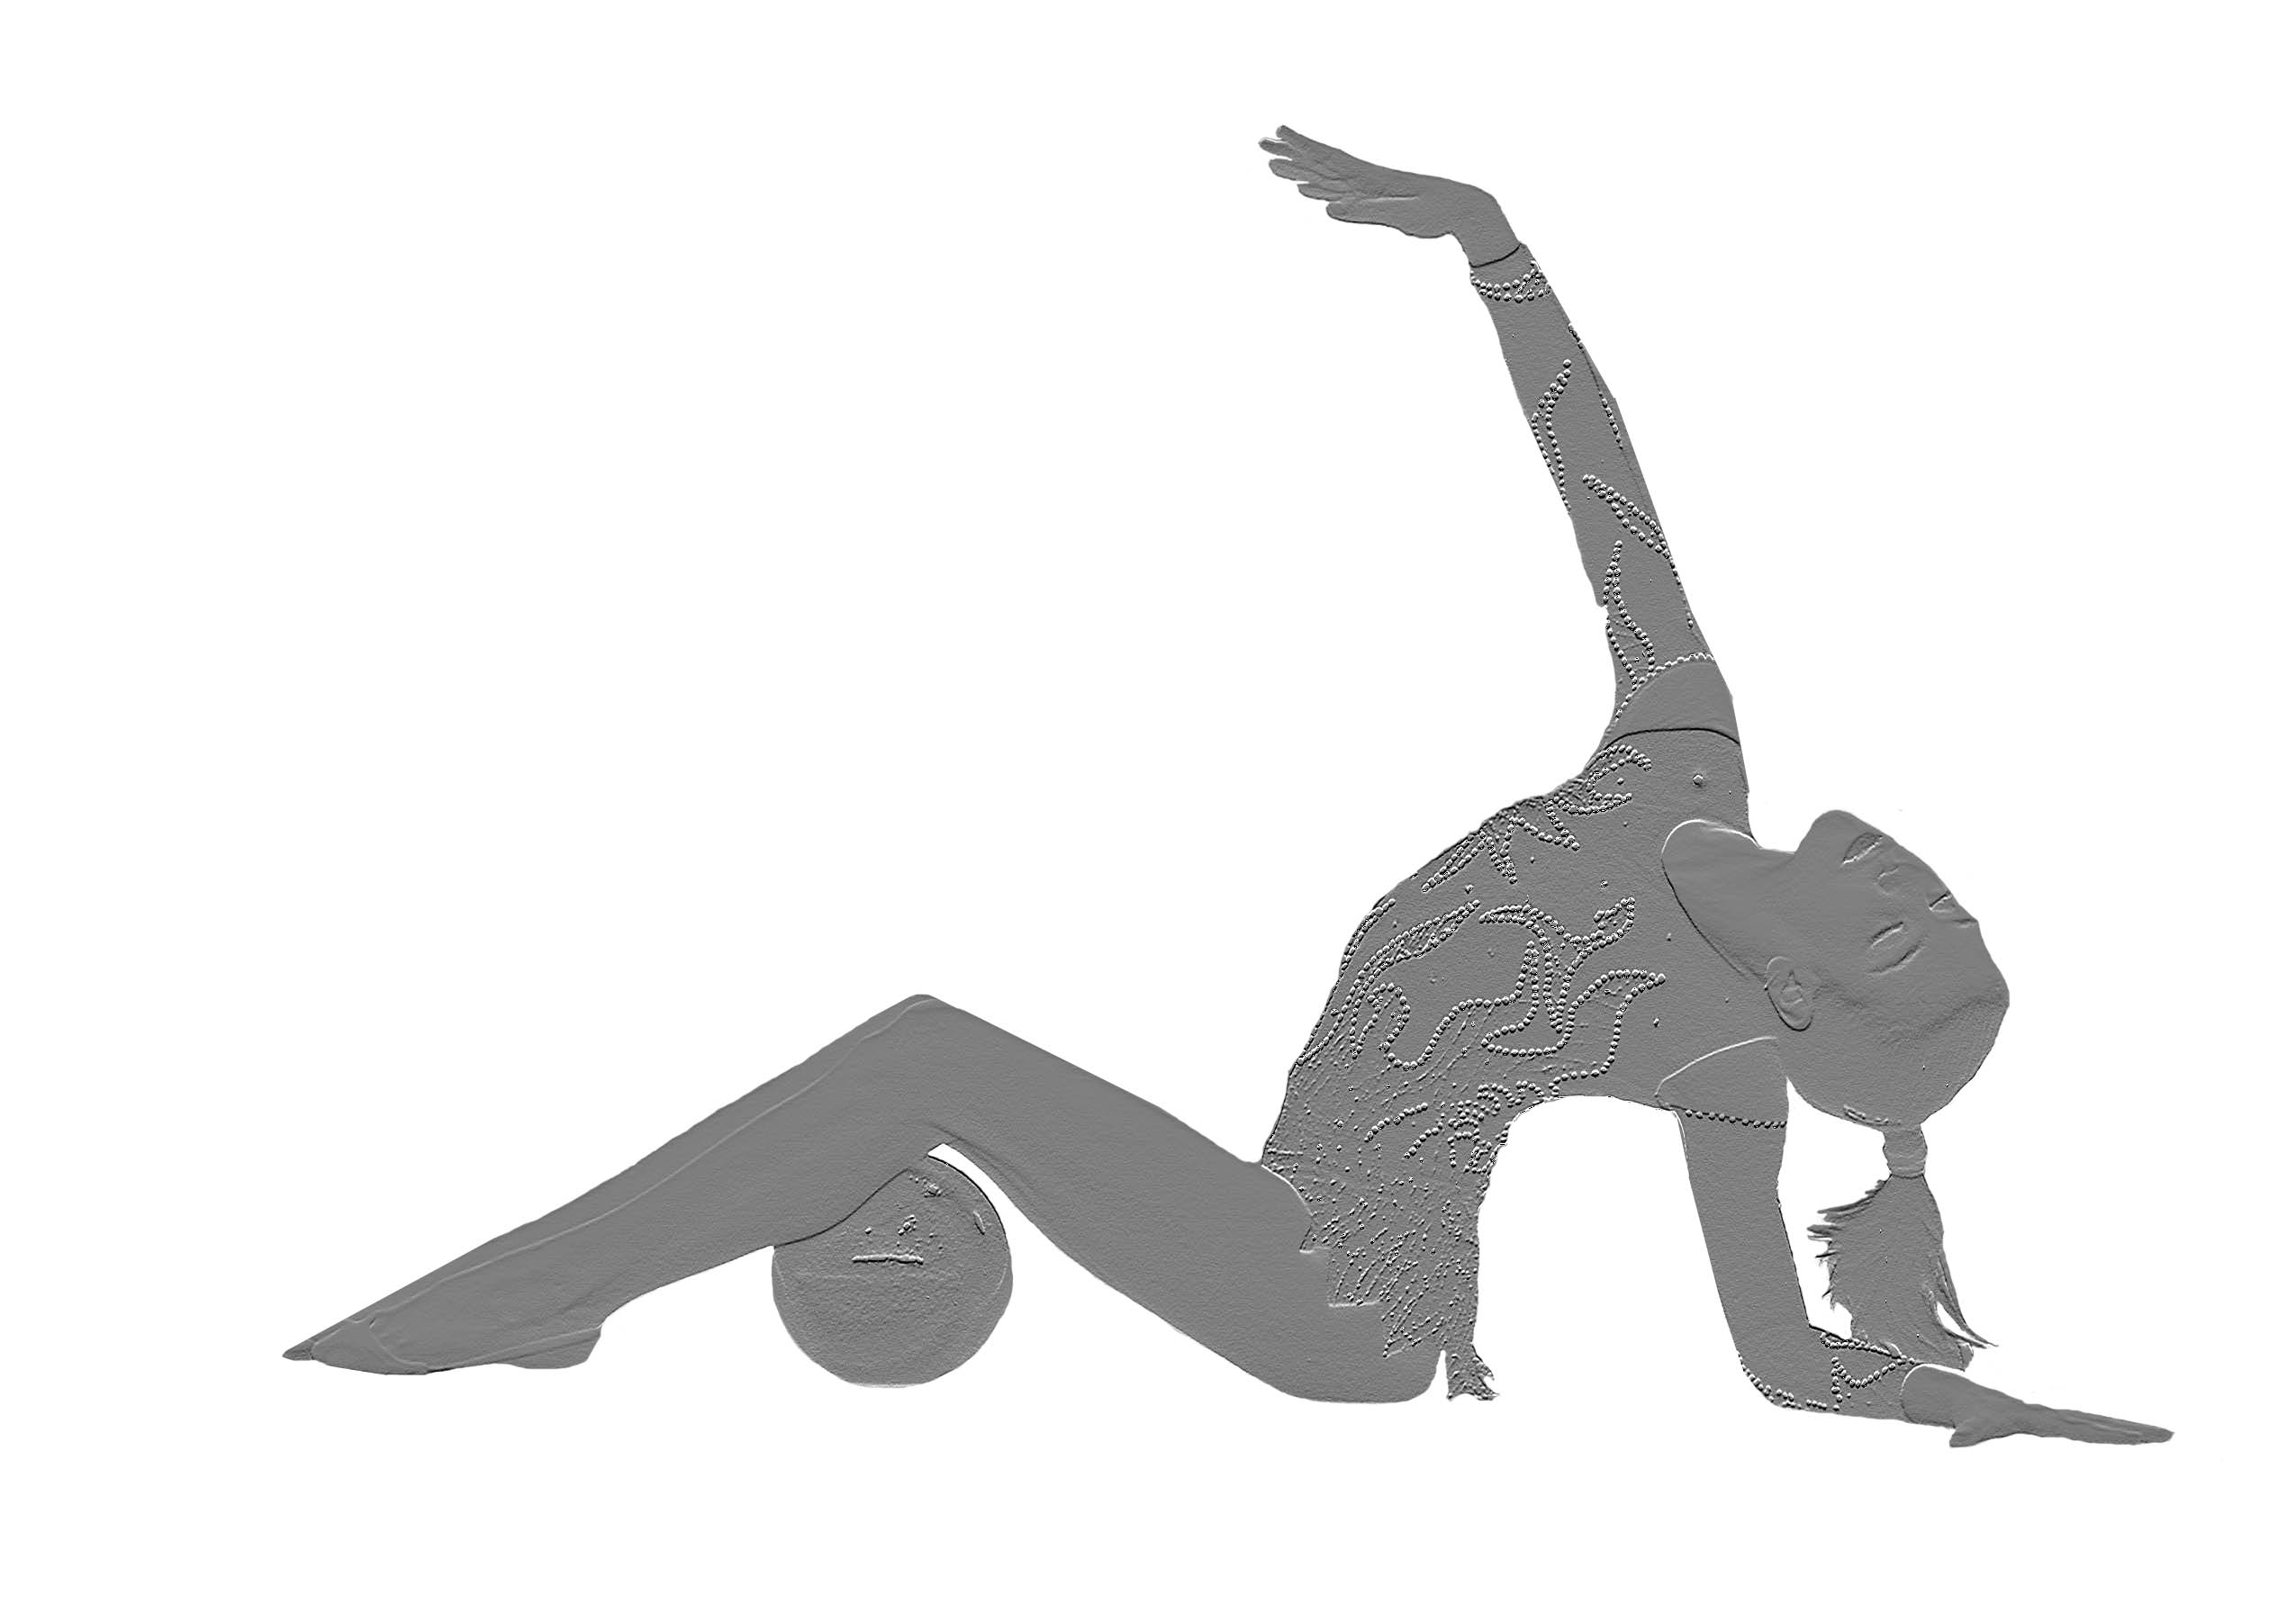
- Groups in position 4 - 8 will be awarded with honor diplomas.
Gala
All Gymnasts are welcomed to participate in a gala performance with a duration of max 3 min.

Visa
If your delegation needs visa for the entry please don’t hesitate to contact us.
The organizers will take care.

- Visa Request form 10/ 05 / 2017
- Gala Performance Entry: 25 / 05 / 2017
- Flight Details : 25/ 05 / 2017
Judges
Each Delegation should bring a judge (international or national) for the event.
Medical service
The organizing committee will provide the medical services.

Cost
Entry fee
• 55 EUR for each Individual Gymnast, 80 EUR for each Group

Accommodation Hotel room (breakfast included+one meal) + transportations
• 5* Hotel
Hotel Nikopolis Thessaloniki
120 EUR per day / per person (double room)
105 EUR per day / per person (triple room)
• 4* Hotel
Hotel SunBeach Hotel Golden Star
Hotel Panorama Hotel Nefeli
75 EUR per day / per person (double room)
70 EUR per day / per person (triple room)
The above prices include:
- Per night stay
- Breakfast & Dinner in hotel
- Transportation from airport to hotel and hotel to airport.
- Transportation from hotel to gym and gym to hotel for all days.
- Snacks at the gym for all participant athletes, coaches and judges.
- Medical personnel & ambulance during competition hours.
- Mementos & gifts for all athletes, coaches and judges.
- “Good bye” Party, for all, after the competition.
The organizer is not covering traveling costs of delegations nor any other expenses made during their stay.
Deadlines
Please send us back the registration form:
- Preliminary Participation: 28/04/2017
- Nominative entry : 10/05/2017
- Hotel Accommodation form: 10/05/2017
- Full payment: 10/05/2017

Payment/Bank details:
ATHLITIKOS OMILOS ARION PANORAMATOS
Account number
0026.0257.28.0201403066
ΙΒΑΝ:GR9802602570000280201403066

Participants cover the costs of accommodation, food and travel expenses themselves.
Organizers cover the costs of tournament, medals, diplomas and additional prizes.

Please, do not forget:
Each delegation must have on arrival:
- Music
All music must be recorded on CD. Please bring two duplicates of each CD clearly labeled (in English) with Country/Club/Name of gymnast/Apparatus.
- Flags
All delegations are kindly requested to bring with them their National Flag.

Last but not least, after the tournament, if you prefer to stay in Greece for vacations,
We can offer various proposals to have memorable vacations in Greece!
Please feel free to contact us for any further information.

We are looking forward to seeing you participating in our tournament in Thessaloniki!
Sincerely,
Elena Kaitezidou, President of the ROYAL Cup
Alex Maikousis, General Secretary of the ROYAL Cup
PAOK sports Arena
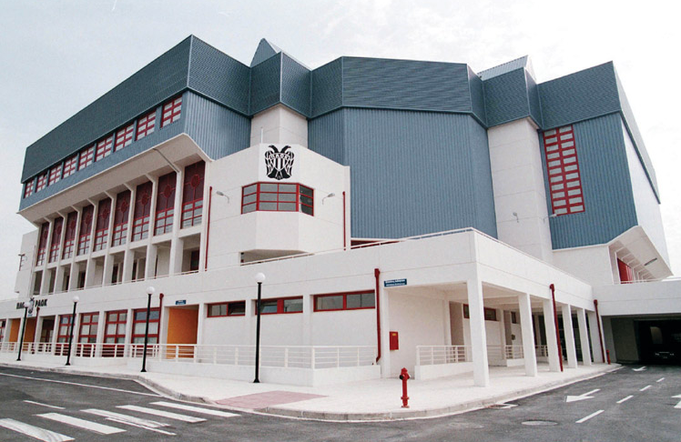
P.A.O.K. Sports Arena is an indoor arena that is located in Pylaia, Thessaloniki, Greece, and it hosts the departments of the multi-sports club P.A.O.K. It was opened in 2000, and in the same year, it hosted the EuroLeague and Greek Cup final-fours. It has 8,500 seats for fans and guests, and has 502 parking spots. The capacity for basketball and volleyball games with standing room, and for concerts is 10,200.

