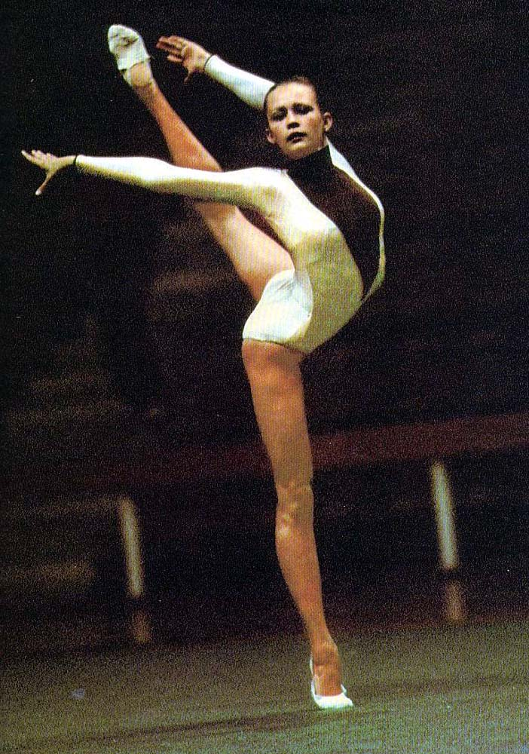

INVITATION

INTERNATIONAL RHYTHMIC

GYMNASTICS TOURNAMENT

VENERA CUP 2016

9-10/06/2016

Ramat - Gan Israel

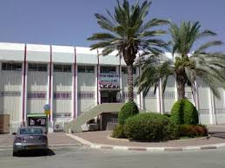

Organizer: Municipality of Ramat – Gan

Competition hall :Sport Hall "ZISMAN-"DEREH

HATAYASIM 85" RAMAT – GAN"

Costs:

Registration fee per gymnast: 40 € per gymnast - Individuals

30 € per gymnast - Groups

Hotel charge:

70 €/person/night (hotel, breakfast + 1 meals)

Transport:
- Organizers provide transportation “Ben-Gurion” International Airport, to Ramat -Gan and back for20 €.
- The organizer is providing the transport from the hotel to the competition hall and back.

Program :

8.06.2016:
- Arrival of delegations
- Training
- Technical and judge meeting
9.06.2016:
- Judge meeting
- All-round competition individual A + B (2010-2004), awards ceremony
- All-round competition groups
10.06.2016:
- Judge meeting
- All-round competition individual A + B (2003-Senior), awards ceremony
- Closing ceremony
- Gala
- Banquet
11.06.2016:
- Trip to the "Dead Sea" (for those who stay, and costs 30 euro per person)
- Departure of delegation

12.06.2016:
- Trip to Jerasulem (30 euro per person)

Categories and Technical Program:

Delegations: 1 gymnast per categories /max 7 gymnasts/ +group
2 coach + 1 judge
Contact:
VeneraZaripova – Levy: veneraz@walla.com
Regina Davidov:dregina@walla.com

General informations

Organization:
Municapality of Ramat-Gan

Event director: Mrs. Venera Zaripova-Levy
Tel.:+972-526775756
E-mail: Veneraz@walla.com

Professional Contact:Mrs. Regina Davidov
Tel:+972-544667992
E-mail: dregina@walla.com

Accreditation will be held at the arrival dal in the hotel.
As well as the rest of the payment will be charge.

GROUP:
Year of  birth | LEVEL A | LEVEL B | Difficulty
Yang starts  (2009-2010) | Without  apparatus | Without  apparatus | D = 3.00 / 6 diff./  4 C x 0.1  Min. 1 S  E=10.00
Hopes  (2008-2006) | By choice | By choice | D = 4.00 / 6 diff./  4 - exchanges  max 1 R ;min 4 C;  Min. 1 S  E=10.00
Children  (2006-2005) | By choice | By choice | D = 6.00 / 6 diff./  4 - exchanges  max 1 R ;min 4 C;  Min. 1 S  E=10.00
Pre junior  (2005-2003) | By choice | By choice | D = 6.00 / 6 diff./  4 - exchanges  max 1 R ;min 4 C;  Min. 1 S  E=10.00
Junior  (2001-2003) | Clubs | By choice | FIG
Senior  (2000+) | Ribbons or  Clubs +Hoops | By choice | FIG

INDIVIDULAS:

Year of  birth | Category A | Category B
Babes  (2009-2010) | W.A or 1app.by choice  (rope, hoop, ball)  D=3.00 (max.7 diff.)  E=10.00 | 1 by choice  (w.a, rope, hoop, ball)  D=2.00 (max.7 diff.)  E=10.00
Yang starts  (2007-2009) | W.A or 1app.by choice  (rope, hoop, ball)  D=4.00 (max.7 diff.)  E=10.00 | 1 by choice  (w.a, rope, hoop, ball)  D=3.00 (max.7 diff.)  E=10.00
Hopes  (2006-2007) | W.A + 1app.by choice  (rope, hoop, ball)  D=5.00 (max.7 diff.)  E=10.00 | 1 by choice  (w.a, rope, hoop, ball)  D=4.00 (max.7 diff.)  E=10.00
Children  (2004-2005) | 2 app.by choice  (w.a, rope, hoop, ball)  D=7.00 (max.7 diff.)  E=10.00 | 1 by choice  (w.a, rope, hoop, ball)  D=5.00 (max.7 diff.)  E=10.00
Pre junior  (2003-2004) | 3app.by choice  (rope,hoop,ball,clubs)  D=8.00 (max.7 diff.)  E=10.00 | 1app.by choice  (rope,hoop,ball,clubs,ribbon)  D=5.00 (max.7 diff.)  E=10.00
Junior  (2001 - 2003) | 3 app.by choice  (rope,hoop,ball,clubs)  FIG rules | 2 app.by choice  (rope,hoop,ball,clubs,ribbon)  D=6.00 (max.7 diff.)  E=10.00
Senior (2000 +) | 4 app  (hoop,ball,clubs, ribbon)  D=10.00 (max.9 diff.)  E=10.00  FIG rules | 2 app.by choice  (rope,hoop,ball,clubs,ribbon)  D=7.00 (max.7 diff.)  E=10.00

INSURANCE: All participants should their own health insurance

REGISTRATION: Definite, Hotel reservation – 20/04/2016

Travel details -5/05/2016
- Each gymnasts must bring flag of her own country plus two copy music disc of each apparatus.

INTERNATIONAL RHYTHMIC

GYMNASTICS TOURNAMENT
DEFINITIVE ENTRY

Name of the Sport Club/Association: …………………………….………………………….………………………

Contact person: …………………….……………………………………….………………………………………………

Your contact address: ………………………………………..……………………………….…………………………..

Tel: ……………………………. Fax: …….………….…………… E-mail………………………………….

Name | Gymnast  Category | Gymnast  Apparatus | Date of birth | Nr passport | Date of expiry
coach
judge

Travelling by plane, bus, train, car

Arrival : Date:………………. Time:……………….

Departure: Date:……………….. Time:……………….

Return this form to organizing committee
E-mail : Venera Zaripova – Levy: veneraz@walla.com and
Regina Davidov dregina@walla.com

